|  |
| --- |
| **CSE3003-Operating Systems-Laboratory-Practical Exercises** |

Date: 27th MARCH, 2021

**Ex.No:1.b) Study of UNIX Commands.**

**Write the Syntax, description, executed Output screenshot of any 25 UNIX commands?**

e.g. format:

**1) Count word in a File:**

Output Screenshot for **Count word in a File:**

: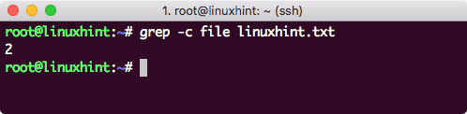

1. **List files:**

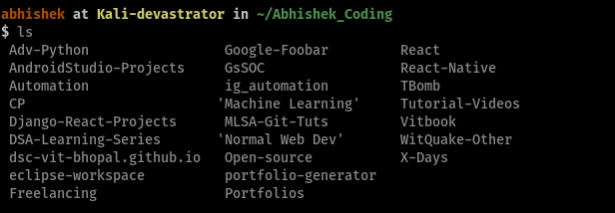

1. **List all files**

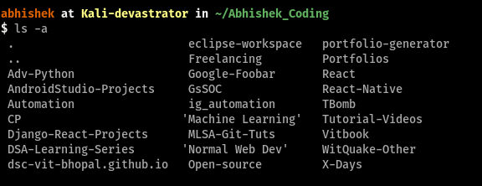

1. **List files in a vertical view**

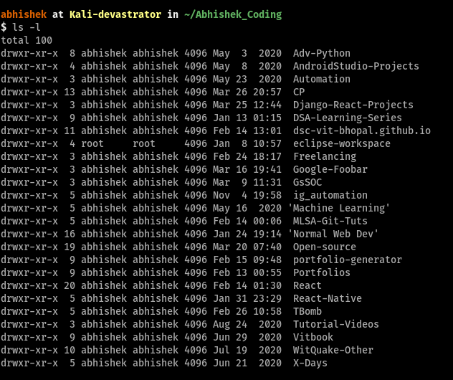

1. **List all files in a vertical view**

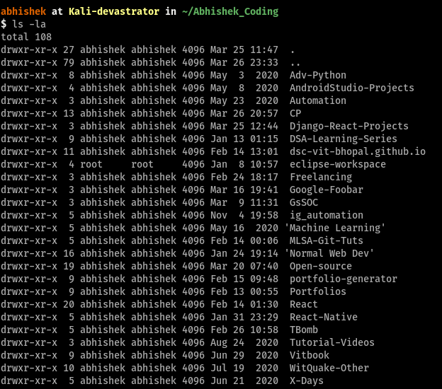

1. **Change file permission**



1. **Manual Instruction**

**“man ls”**

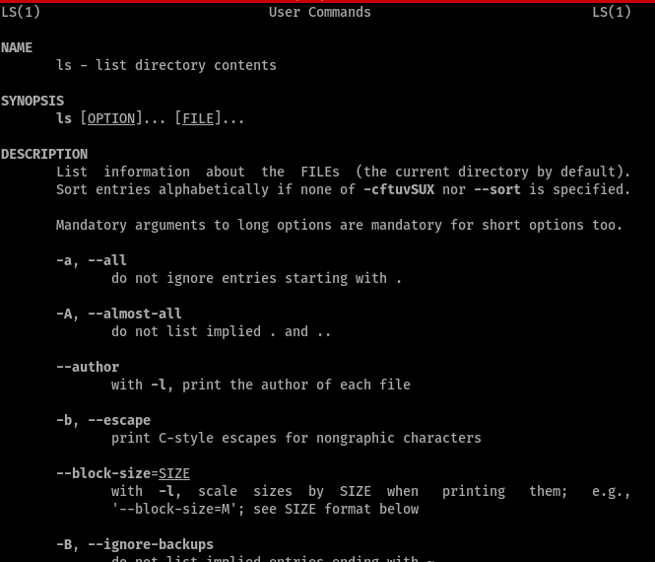

1. **Who**

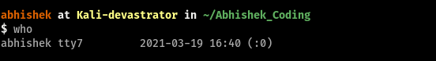

1. **Printing (echoing)**

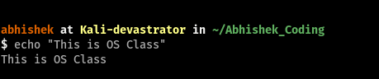

1. **Change Directory**

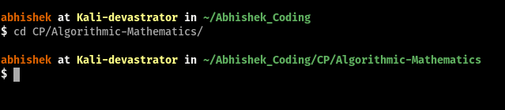

1. **Go Back in the directory**

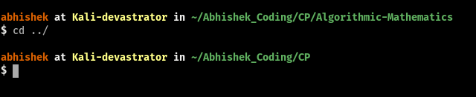

1. **Make Directory**

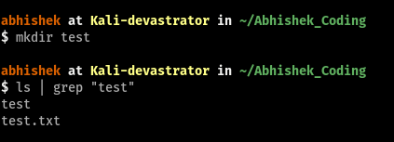

1. **Open nano Editor**

**“nano file.txt”**

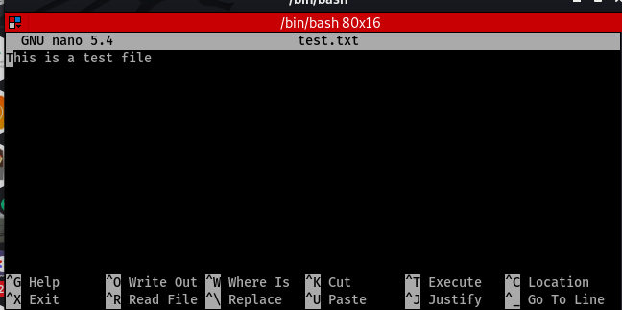

1. **Open Vim Editor**

**“vim file.txt”**

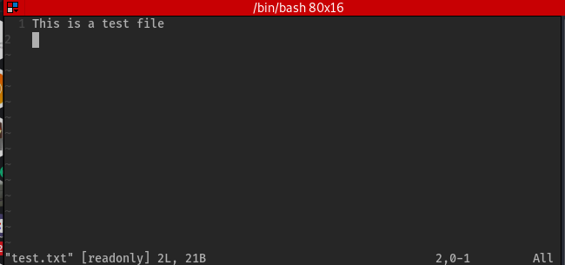

1. **uname**

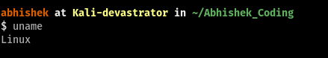

1. **Show content of a file**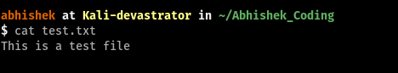
2. **Grep**



1. **Delete a file**

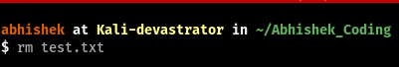

1. **Delete a Directory**



1. **Rename a Directory**



1. **Move a Directory**



1. **Process**

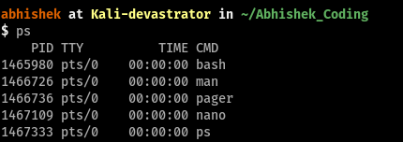

1. **top**

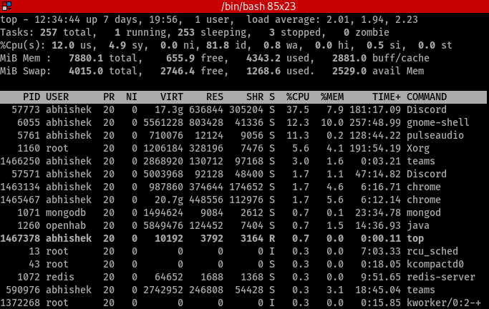

1. **htop**

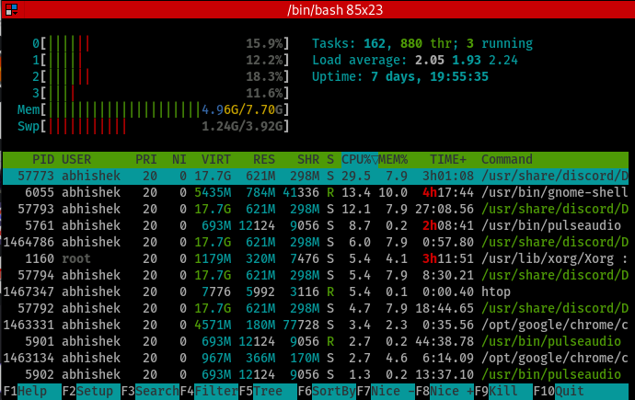

1. **Present Working Directory**

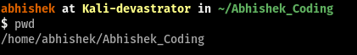

1. **clear**

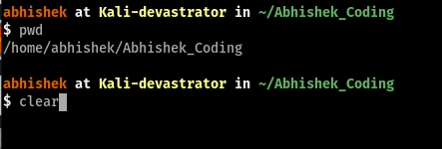

|  |
| --- |
| **Name of the Student: ABHISHEK SRIVASTAVA Reg. No: 19BCE10071** |